 

**Placement Empowerment Program**

***Cloud Computing and DevOps Centre***

**Use Cloud CLI Tools Install the CLI for your cloud provider (e.g., AWS CLI). Use it to list resources, upload files to storage, and manage VMs.**

Name: Jaswanth Saravanan Department:ADS



Introduction :

Cloud command-line interface (CLI) tools, like AWS CLI, enable users to interact with cloud services directly from the terminal, facilitating automation and efficient resource management. This task includes installing AWS CLI, configuring it with AWS credentials, and executing basic operations such as listing resources, uploading files to S3, and managing EC2 instances. By providing a faster, scriptable alternative to the AWS Management Console, CLI tools enhance productivity.

**Objective:**

The goal of this project is to:

1. Learn Cloud CLI Basics – Install and configure AWS CLI to interact with cloud resources using command-line commands.
2. Manage Cloud Resources – Use AWS CLI to list cloud resources, upload files to S3, and manage EC2 instances efficiently.
3. Enhance Automation Skills – Gain hands-on experience in automating cloud tasks, improving efficiency over manual AWS Management Console operations.

**Step-by-Step Overview**

**Step 1:**

Search for "AWS CLI Installer for Windows" on Google and download the required version**.**

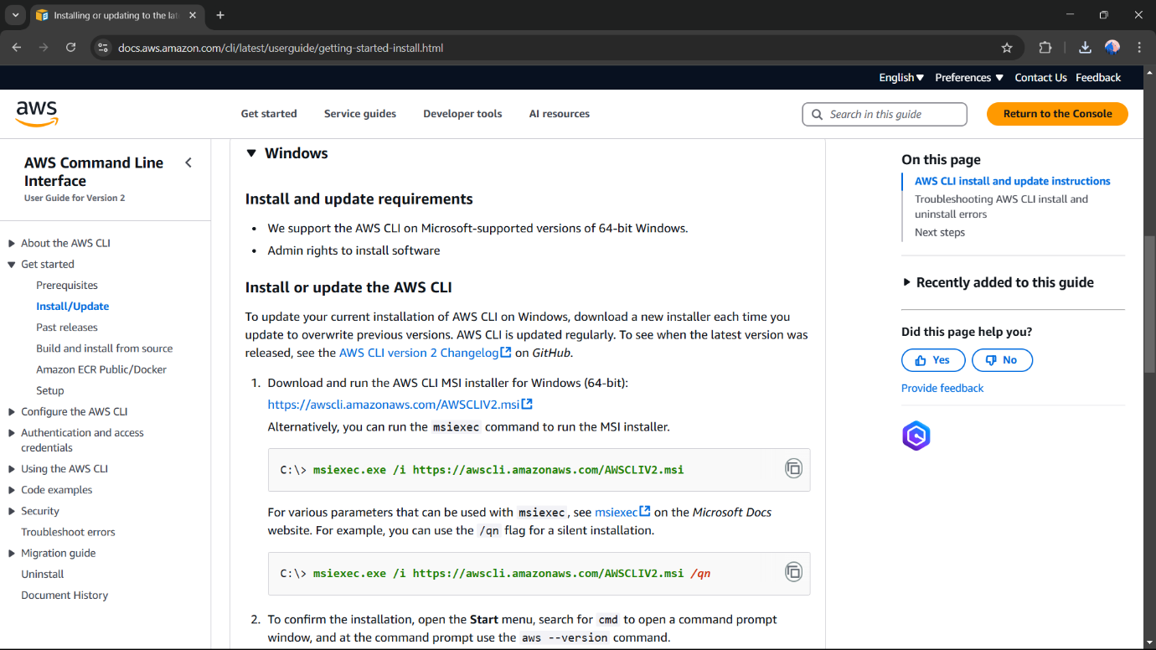

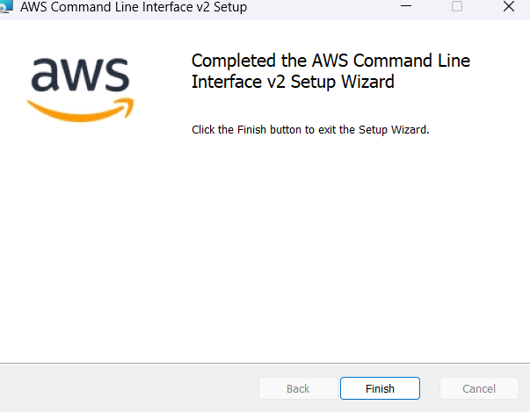

Step 2:

Once installed, verify the installation by opening Command Prompt (cmd) or PowerShell and running **aws --version**

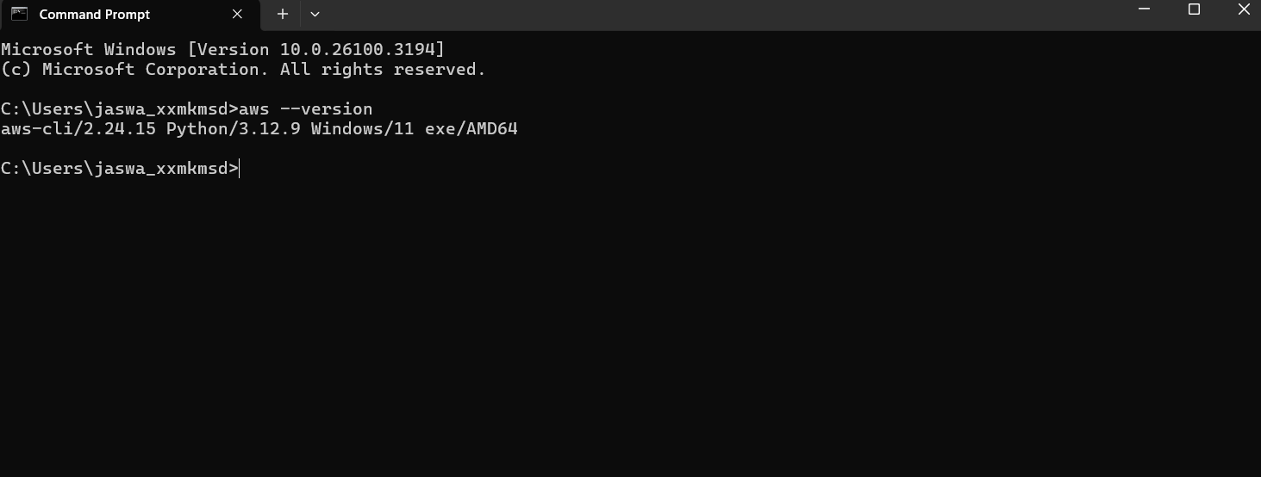

Step 3:

Open the Aws console and create IAM user , and retrieve the access key

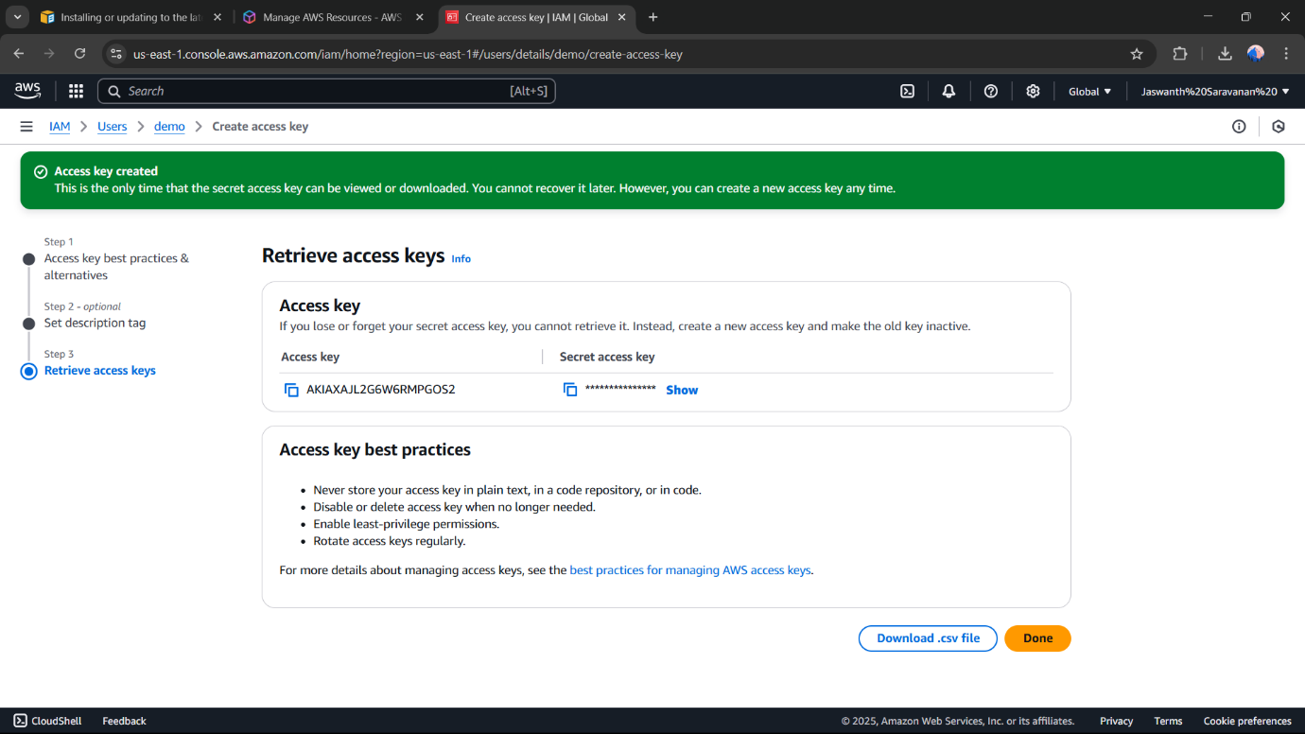

Step 4 :

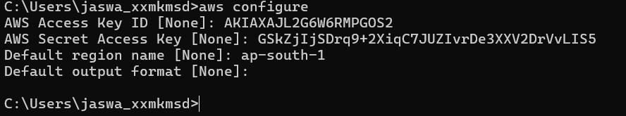

AWS Access Key ID → Get it from AWS IAM > Security Credentials

AWS Secret Access Key → Get it from AWS IAM > Security Credentials

Default region name → Example: us-south-1 (Find yours in AWS Console)

Default output format → Keep it as json or press Enter for default.

Step 5:

To see all storage buckets, Type **aws s3 ls** in cmd

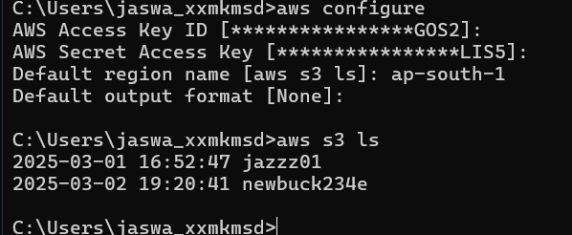

There are two buckets.

Step 6:



Create an S3 Bucket by typing **aws s3 mb s3://your-unique-bucket-name** in cmd

Step 7:

Upload a file to S3 Bucket by typing **aws s3 cp yourfile.txt s3://your-unique-bucket-name/** in cmd



By typing this command file will be uploaded in your s3 bucket.

Step 8:

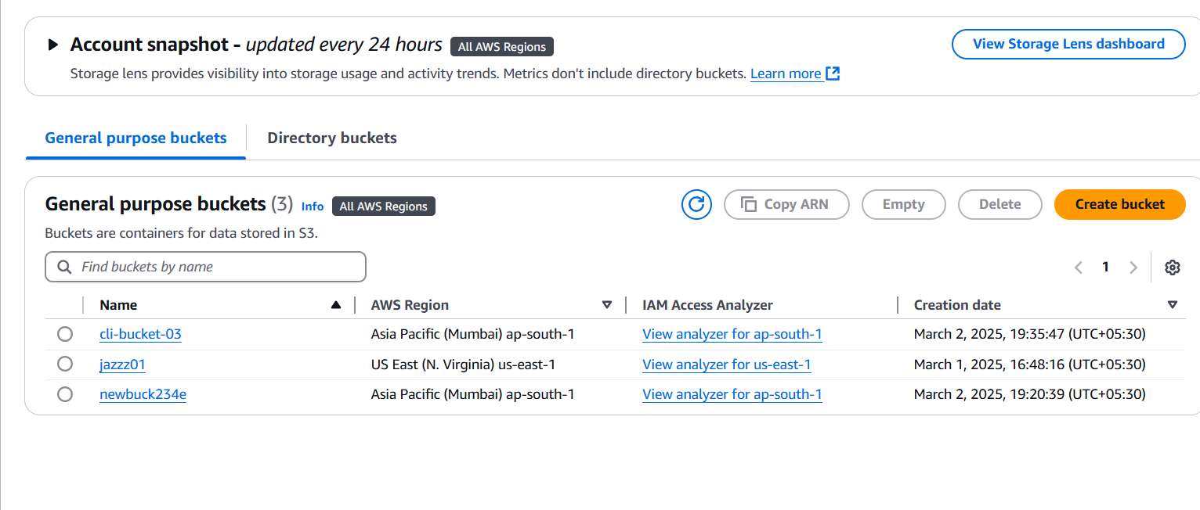

The new bucket is added(cli_bucket-03)

Step 9:

The file that I uploaded from the CLI is added to my bucket which I created.

**Expected Outcome**

By completing this POC, you will:

1. ***Successful Installation & Configuration*** – AWS CLI will be installed and configured with the correct credentials, allowing seamless interaction with AWS services.
2. ***Ability to List Cloud Resources*** – You will be able to list AWS resources such as S3 buckets, EC2 instances, and IAM users using CLI commands.
3. ***File Management in S3*** – You will gain hands-on experience in uploading, downloading, and managing files in Amazon S3 using the CLI..
4. ***Improved Automation Skills*** – By using CLI instead of the AWS Console, you will develop automation capabilities essential for DevOps and cloud computing.